Report

1. Screenshot

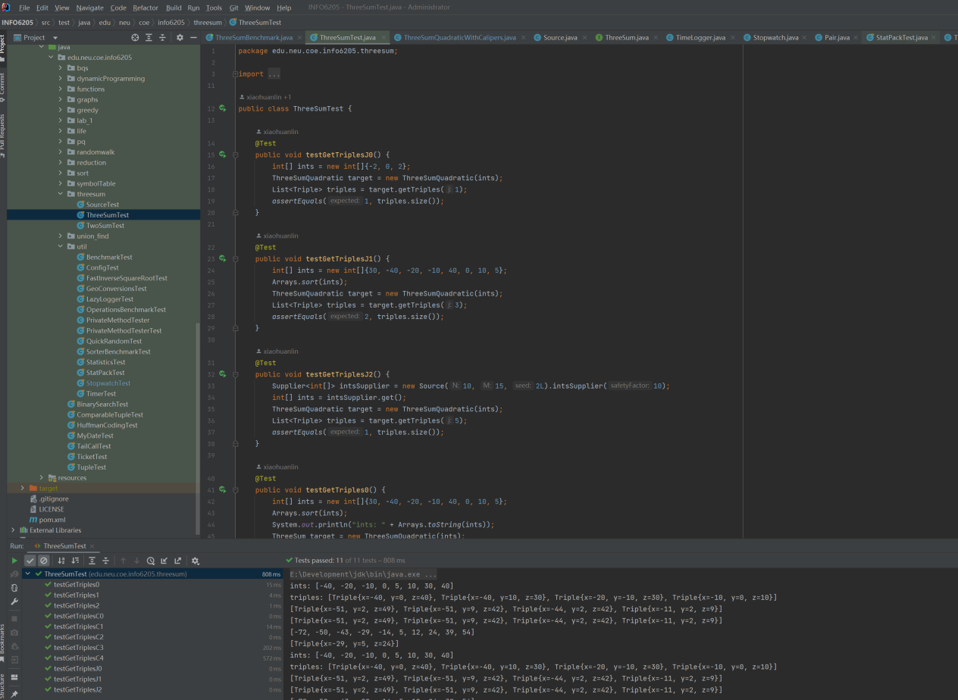

1. Spreadsheet

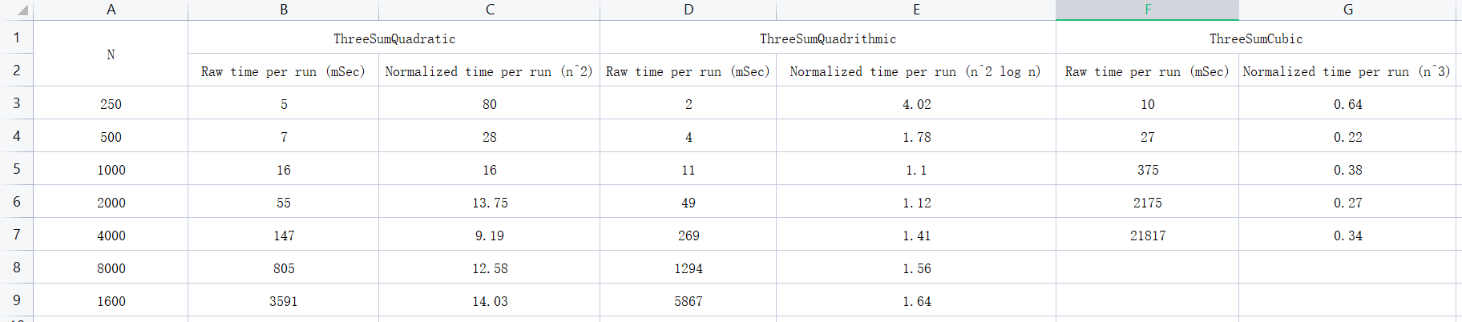

1. Explanation

The brute force algorithm uses a nested three-level loop, which enumerates all three combinations of numbers in the array, with a time complexity of O(n^3). The quadrithmic method uses a two-level loop and Binary Search with a time complexity of O(n^2 log n). The quadratic method is an optimization of the brute force algorithm, which uses a two-level loop and the method of two pointers and has a time complexity of O(n^2). By timing the three methods, I can see that the brute force method takes the longest time and the quadrithmic method takes less time until log n equals 1, but when the length of the tested array is large, the quadratic method obviously takes the least time, so the quadrithmic method is the most effective in solving the sum of three numbers problem.